Zebrafish Fin Regeneration Classroom Experiment
By Jamie Nosbisch, Phyo Ma, Arthur Reynolds, and Sooji Katie Jo

Background Information

The purpose of this lab is to learn more about the process of regeneration and the molecular mechanisms behind tissue growth. Zebrafish are popular model systems for regeneration experiments due to the ease with which they can be maintained in a laboratory setting as well as their ability to quickly regenerate many body parts and organs. In this experiment, hypotheses regarding regeneration will be tested by making cuts to the caudal fin of zebrafish and then observing the regeneration process over the course of a few weeks.

Regeneration, the process of replacing missing tissues, is a fascinating and mysterious phenomenon. Observing starfish or newts regenerating entire limbs is astonishing to behold and makes you wonder why humans are incapable of such feats. What if humans had the ability to restore their own damaged or severed arms and legs, regrow diseased organs, or restore cells lost to age, disease, or trauma? Answering these questions has been the source of countless hours of research and experimental study for over a hundred years, and while extensive knowledge has been produced on this topic, many questions are still left to be answered.

Regeneration covers a number of different processes and is found in all species in one way or another. There are four major ways regeneration is believed to take place. Stem-cell mediated regeneration involves the continual replacement or growth of cells from stem cells to regrow certain organs or tissues. In humans, this process is responsible for producing new blood cells and why our hair is constantly growing. A second form of regeneration is epimorphosis in which a cell mass becomes undifferentiated so that it can redifferentiate to form a new structure. This process is how newts regenerate their lost limbs. Morphallaxis, a third regeneration process, is how Hydra are able to regenerate and this involves repatterning existing tissues. Unlike morphallaxis, epimorphosis involves very little new cell growth. The final regeneration possibility is compensatory regeneration in which normal differentiated cells simply divide and maintain the function of the original cells. This process is characteristic of the human liver which is the only internal human organ capable of regeneration.

While a better understanding of regeneration is not only something that will help satisfy our curiosity regarding this amazing phenomenon, it has the potential to be used in a number of important applications. An entire field of medicine called regenerative medicine is dedicated to studying the mechanisms of regeneration and trying to apply this information to repair and restore healthy function to human organs and tissues. Using stem cells and model organisms to study regeneration a number of important findings have been made in recent years, particularly in understanding the molecular mechanisms and pathways involved in the regeneration process. We, too, can conduct our own experiments with model organisms, using organisms like the zebrafish, to gain a better understanding of how regeneration works.

Zebrafish are a useful model to study cellular regeneration in vertebrates due to their ability to reconstruct amputated organs and tissues including the heart, scales, caudal fin, retina, and spinal cord. Caudal fins are a common choice for studying regeneration, particularly for students, because of their easy accessibility, fast regeneration rate, and relatively simple structure. Zebrafish caudal fins are composed of segmented bony rays, inter-ray mesenchymal tissue, and enclosing epidermal tissues. Each fin ray is composed of two hemirays and an inner space filled with intra-ray mesenchymal cells (Fig.1). These bony rays are made from bone matrix secreted by osteoblasts.
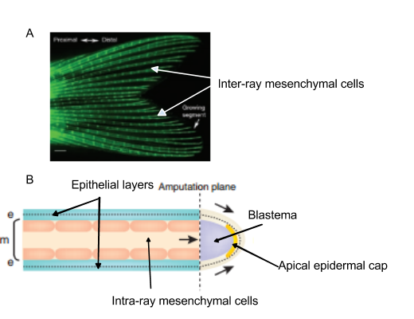
Figure 1: The anatomy of the zebrafish caudal fin and detailed cartoon of each fin ray. (A) Zebrafish caudal fin stained with calcein so that fin rays are visible. (B) Cartoon of a longitudinal section of a single amputated fin ray. Cells from epithelium layers (blue) move to cover the amputated area, and form the epidermis (side arrow) and apical epidermal cap (AEC). The intra-ray mesenchymal cells also move toward the amputated area (middle arrow), and form immature blastema (purple). (Iovine 2007)

When a caudal is damaged due to a cut or an attack from other organisms, it takes about two weeks to regenerate a fully functioning fin. Once the fin is cut, the epithelial cells migrate to cover the wounded area. After approximately one day, the apical epidermal cap (AEC) is formed at the amputated area. Under the apical epidermal cap, a mass of undifferentiated mesenchymal cells accumulate and form a blastema. The next two steps of regeneration are proliferation and differentiation. The blastema segregates into two groups: slow distal blastema and fast proximal blastema. The slow distal blastema proliferates to form the new outgrowth and makes daughter cells for the proximal blastema. Within 48 hours of the amputation, the cells in the blastema start to differentiate and construct the original tissue structure.

The reconstruction of the caudal fin is a fascinating process at both the physical and molecular level; however, some of the molecular pathways involved are still unknown. In most vertebrates, the blastema formation is conserved and is required to regenerate the amputated part. If there is no blastema formation, regeneration will not happen, and a scar will form at the amputated area. Regeneration starts with the the establishment of two signaling centers: the dorsal blastema and the lateral basal epidermal layer. Fibroblast growth factor receptor 1 (Fgfr1), Wnt-β-cadherin, and BMP are protein signals that are required to set up the two signaling centers. Inhibition of either Fgfr1 or Wnt-β-cadherin prevents the establishment of the lateral basal epidermal layer. Once the signaling centers are established, Fgfr1 in the dorsal blastema produces muscle segment homeobox B (msxb), which regulates cell proliferation in the regenerating region. Muscle segment homoebox B (msxb) is also regulated by Bmp, specifically Bmp4. Reducing the amount of Bmp4 in the distal blastema also decreases msxb expression in the dorsal blastema. Therefore, cell proliferation and outgrowth of the dorsal blastema requires the Fgfr1, Wnt-β-cadherin, and Bmp signaling pathways. After the two signaling centers are set up, sonic hedgehog (shh) is produced in the lateral basal epidermal layer to regulate patterning and bone cell proliferation for the outgrowth. Surprisingly, inhibition of shh expression causes decreased expression of msxb; thus, msxb is likely the product of cross-talk between shh in the basal epithelium and Fgfr1 in the dorsal blastema. The summary of these signaling pathways are shown in figure 2.
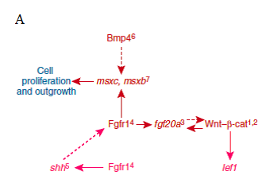
Figure 2: The summarized scheme of signaling pathways in the distal blastema and the lateral basal epidermal layer of regenerating fins. Muscle segment homeobox b (msxb) is important for cell proliferation and outgrowth, and is related to BMP and Fgfr1 along with shh. (Iovine 2007)

Using knowledge of zebrafish caudal fin regeneration, many experiments can be performed at either the physical or molecular level. Students can study the rate of regeneration of different organs in zebrafish, the pattern of caudal fin regeneration with different cuts, the outcome of removing the AEC, or the effects of altering the expression of Fgfr1, Wnt-β-cadherin, Bmp4, shh, or msxb.

Instructor Information
This is experiment can serve as a high school or undergraduate experiment. Students will learn about the processes of regeneration in zebrafish. The students will be using razor blades in this experiment, so they should be precautioned on the use of sharps in experimentation. This experiment can run for up to 2 weeks depending on the amount of fin amputated.

Materials:
- Sterilized razor blades
- Tricaine solution
- Fish tanks
- Fish net
- Petri dish
- Ruler
- Dissecting microscope (recommended)

Methods:
1. Set up two fish tanks. One containing water, to house the fish you will be using in this experiment, and the other containing Tricaine solution, which will be used to anesthetize the fish.
2. Place the fish that you will be using in this experiment into the housing fish tank.
The amputation procedure works best when done one fish at a time, so steps - should be fully completed for each fish before continuing on to the next. It is important to wear gloves when using Tricaine solution as it can be toxic.
3. Net one fish and place it into the Tricaine solution to anesthetize it. It is recommended that you place your hand over the net while transferring the fish, in order to prevent the fish from jumping out of the net.
4. Once the fish has stopped swimming and turned onto its side, remove it from the Tricaine. Place the fish onto a petri dish.
5. Place the petri dish under the dissection microscope, and prepare the razor blade for amputation.
6. In one firm motion amputate the caudal fin in the desired manner. The figure below provides some potential cut sites.

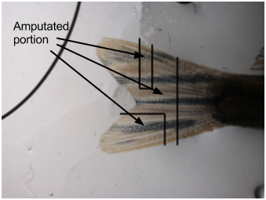

Figure 3: Potential cut sites for class experiments. Three potential cut sites for experimentation, testing proximal vs. distal regeneration.

7. Return the fish to the housing tank so that it can recover.
8. Observe the regenerative progress using a ruler over a chosen period of time.
Ex: once per week, once per day, etc.
It is recommended that the progress be checked often to obtain good results.

Refer to Common Laboratory Techniques as necessary.

Getting started:
1. How to maintain a zebrafish laboratory
2. How to feed zebrafish
3. Raising babies
4. Baby feeding experiment
5. The embryo swirl
6. How to mate zebrafish
7. How to label tanks
8. Gender identification guides
9. Example fish facility designs

Animal Protocols:
1. Example Standard Operating Procedure
2. Example IACUC Protocols

Preparing for Microscopy:
7. How to use anesthetics on zebrafish

Molecular and other techniques:
3. Fin clips

References

Fields et al. (2009) Danio rerio in K-12 Classrooms: Sparking Interest in the New Generation of Scientists. Zebrafish 6: 145-160

Gilbert, S. Developmental Biology, 9th ed.; Sinauer Associates, Inc.: Massachusetts, 2010; pp 560-571

Iovine M (2007) Conserved mechanisms regulate outgrowth in zebrafish fins. Nature Chemical Biology 3(10): 613-618

Lee Y, Grill S, Sanchez A, Murphy-Ryan M, Poss K (2005) Fgf signaling instructs position-dependent growth rate during zebrafish fin regeneration. Development 132: 5173-5183

